Software Architecture Diagram Examples

No standard versions as you can see – you can pick one of these or build your own.

Boxes represent components

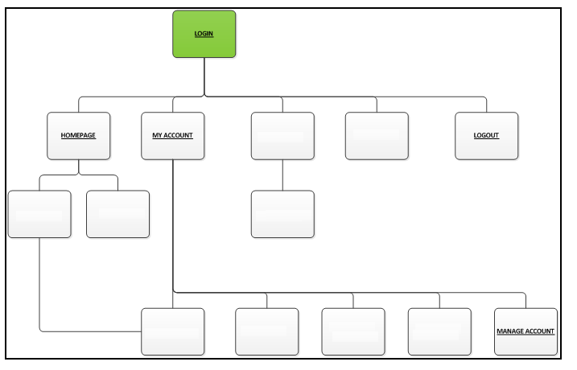



Blue boxes would represent programs in the system

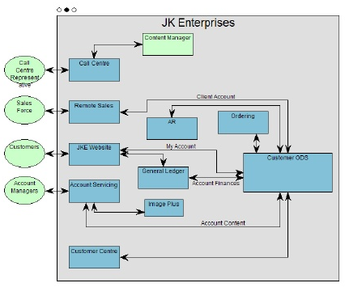



Grey boxes represent components/programs/interfaces

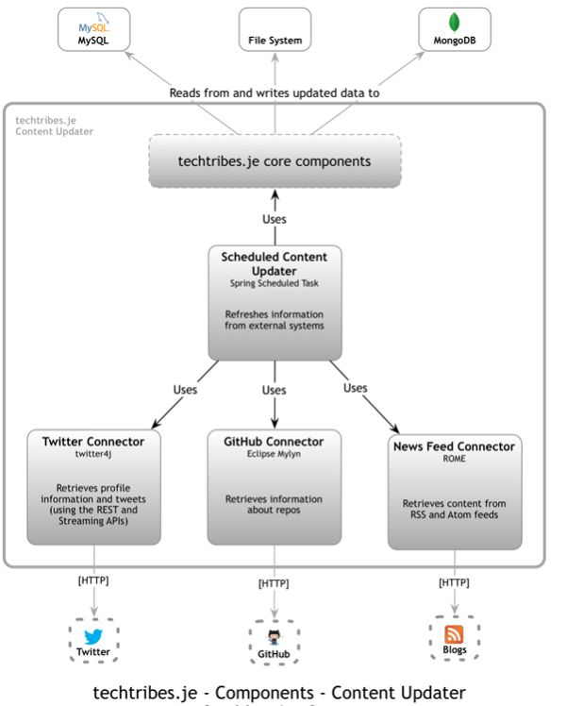

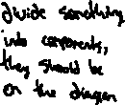

Components based on selecting icons/buttons

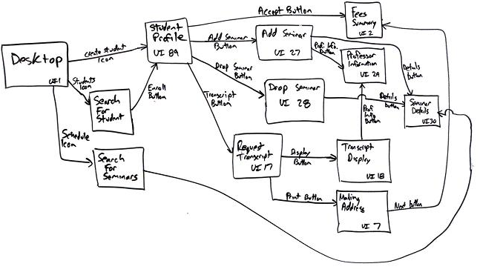

Rectangles represent components

